CATE Executive Elections – 2022
- Vice-President (2 year term 2022-2024)
- Secretary-Treasurer (2 year term 2022-2024)
- Communications Co-Director (Social Media) (2 year term 2022-2024)
- Member at Large (2 year term 2022-2024)
- Graduate Student Representative (2 year term 2022-2024)

- Non-Executive Positions to be filled at AGM
- · CATE Rep on New Scholars Committee (2 year term 2022-2024)
- · CATE Award for Research in Teacher Education (2 year term 2022-2024)

Position | Name, Institution, Statement, Brief Biography | Photo
Vice-President | Nominee: Sheryl MacMath, Professor  Membership Number: 47650 (CSSE)  Institutional Affiliation: University of the Fraser Valley, BC  Statement of Intent:  I have been involved with CATE as a member, presenter, and reviewer for more than a decade. In recent years I began to explore moving beyond participation to providing support for the association itself. A number of my current research interests have emerged out of presentations and resources provided by CATE over the years. My involvement as a contributing author to the last two CATE polygraph series has inspired me to move beyond representing CATE to providing more substantive support to my fellow teacher educators. In recent years I have been the CATE representative on the Awards Committee for Contributions to Teacher Education Research, the CSSE New Scholar Committee, and the Canadian Journal of Education Board of Consulting Editors. Over the last few years I have worked with Philippa Parks as a Member-at-Large. Together we planned and facilitated this year’s pre-conference and panel presentations. As such, I am putting my name forward for the role of vice-president (VP). I believe we are at a critical juncture in teacher education given the release of last year’s Ignite Report identifying a number of action items in relation to equity, diversity, inclusion, and decolonization. These issues are close to my heart and have guided my research interests these past few years. I have worked with amazing Indigenous Elders, educators, and scholars, along with educators with lived experiences as members of underrepresented groups in teacher education. I see my role as bringing issues of equity and justice to the forefront of discussions, while ensuring that the voices of those that have often been silenced in teacher education have a platform to share their experiences. I see the role of VP in CATE as a unique opportunity to accomplish these goals. I understand that this is a six year commitment and am excited at the prospect of working closely with my colleagues as we support current and future teacher educators and researchers. Thank you for considering my nomination.  Brief Bio:  Sheryl MacMath is a Professor at the University of the Fraser Valley (UFV) in the Teacher Education Department. She has been teaching courses in planning, assessment, evaluation, and reporting; elementary math methods; elementary social studies methods; and classroom management for over a decade. As part of her role at UFV, Sheryl is also responsible for observing, mentoring, and evaluating teacher candidates in the field on practicum. This has enabled a strong connection with the field leading to regular workshops for K – 12 teachers working throughout the Fraser Valley. Working in and with the field is a passion for Sheryl. She believes that, to meet the needs of the unique students in our schools, we need teachers who are not only knowledgeable and effective, but also empowered and inspired. This means making visible the theory and research that support best practice so that teachers are able to make their own informed, reflective decisions regarding their classrooms and students. Sheryl’s research interests, beyond her teaching scholarship, include peer refereed conferences and journal publications in teacher education programming; intake and admission procedures; project based learning, design thinking, and curriculum integration; and the Indigenization of curriculum and the decolonizing journey of self. Prior to her work at UFV, Sheryl was a sessional instructor for UVic’s Faculty of Education in both the departments of Educational Psychology and Leadership Studies, and Curriculum and Instruction. Her PhD was completed at the Ontario Institute for Studies in Education at the University of Toronto with her dissertation focusing on the use of curriculum integration to support at-risk students in schools. | 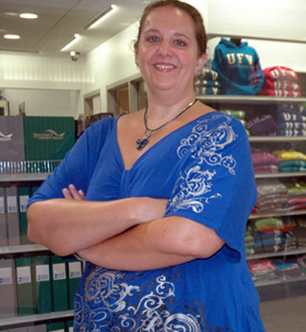
Vice-President | Nominee: Philippa Parks  Institution: Université de Sherbrooke, Quebec  Philippa Parks is an assistant professor in the Faculty of Education at the Université de Sherbrooke, Quebec. Her research looks at how language teachers form their professional identity during teacher education, particularly how they build self-efficacy and resilience, and how teacher education programs can help to address the shortages of teachers across Canada.  Philippa has been actively involved in the CATE since 2018, when she joined the executive in the role of Social Media and Communications co-coordinator and graduate student representative from 2018 to 2020. In the past year, she has served as one of CATE’s members-at-large. As a result of these roles, over the past five years Philippa has been responsible for promoting CATE’s work through social media, for organizing CATE’s graduate student events in 2019 and 2021, and for this year’s pre-conference and panel events for CATE. This year, she is also a part of the committee responsible for organizing the World Federation of Associations of Teacher Education (WFATE) to be held in Canada in 2023.  In addition to her work at CATE, Philippa has held the position of programming co-director at the Canadian Association for the Study of Women in Education (CASWE) since 2017 and has been the national council representative for Quebec for the Canadian Association of Second Language Teachers (CASLT) for Quebec since 2018.  As a result of these experiences, Philippa has strong background in coordinating projects between teachers from across Canada, and in organizing conferences and programming. She is also fully bilingual. She hopes to bring these skills to the role of Vice-President of CATE for the upcoming 2022-2024 mandate.  Philippa Parks est professeure adjointe à la Faculté d'éducation de l'Université de Sherbrooke, au Québec. Ses recherches portent sur la façon dont les enseignants en langues forment leur identité professionnelle au cours de la formation des enseignants, en particulier sur la façon dont ils développent leur auto-efficacité et leur résilience, et sur la façon dont les programmes de formation des enseignants peuvent contribuer à remédier aux pénuries d'enseignants à travers le Canada.  Philippa participe activement au ACFE depuis 2018, lorsqu'elle a rejoint l'exécutif dans le rôle de coordinatrice des médias sociaux et des communications et de représentante des étudiants diplômés de 2018 à 2020. Au cours de la dernière année, elle a occupé le poste de « Member at large ». Grâce à ces rôles, Philippa a été chargée, au cours des cinq dernières années, de promouvoir le travail du ACFE par le biais des médias sociaux, d'organiser les événements des étudiants diplômés du ACFE en 2019 et 2021, ainsi que les événements de pré-conférence et de panel du ACFE de cette année. Cette année, elle fait également partie du comité responsable de l'organisation de la Fédération mondiale des associations de formation des enseignants (WFATE) qui se tiendra au Canada en 2023.  En plus de son travail au ACFE, Philippa occupe le poste de codirectrice de la programmation à l'Association canadienne pour l'étude des femmes en éducation (ACÉFÉ) depuis 2017 et est la représentante du conseil national pour le Québec de l'Association canadienne des professeurs de langues secondes (ACPLS) depuis 2018.  Grâce à ces expériences, Philippa possède une solide expérience dans la coordination de projets entre enseignants de tout le Canada, ainsi que dans l'organisation de conférences et de programmes. Elle est également bilingue. Elle espère apporter ces compétences au rôle de vice-présidente de l'ACFE pour le prochain mandat 2022-2024. | 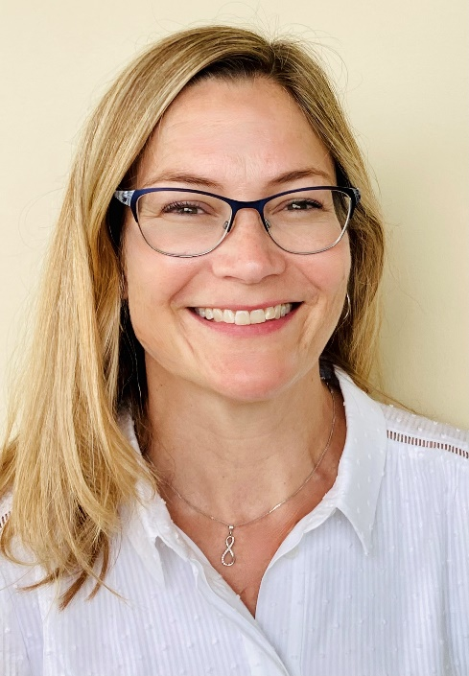
Vice-President | Nominee: Noah Khan  Institution: MEd Student York University  Noah Khan is a current MEd student at York University, starting his PhD studies at UT/OISE in Social Justice Education in September. He is a SSHRC Doctoral Fellow and United Nations SDSN Youth Local Pathways Fellow. He has specific interests in teacher education, focusing heavily on the intersection of philosophy of technology and teacher education. Noah has presented his work on the philosophy of technology and how it bears on teacher education at multiple conferences, most recently presenting on Online Imperialism and International Education at CIES 2022. He has significant experience in leadership positions, having led the student political body in his academic program and served on his graduate program's executive committee and faculty council. He is currently one of two graduate student representatives on the 2023 Congress Scholarly Planning Committee, has co-organized an international symposium on multilingual assessment, and serves on multiple committees within various scholarly associations. Noah is incredibly excited to put his wide range of skills and experiences to use in the service of the CATE's generative work. | 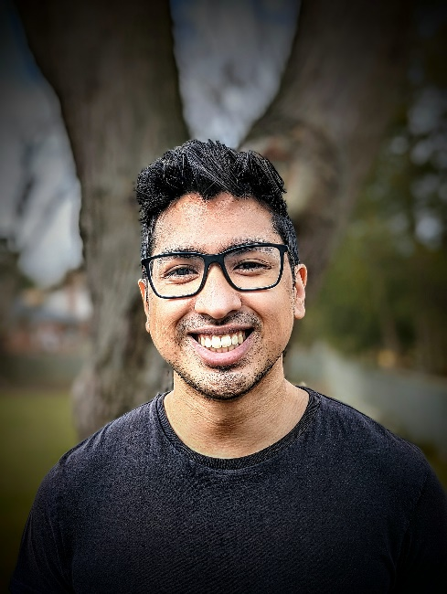

Secretary-Treasurer | Nominee: Julia Rheaume  Institution: Red Deer Polytechnic  I have held the role of Secretary/Treasurer since May 2020 and would like to be considered as a candidate to continue in this role. Over the past two years, I have applied my excellent organizational, communication, and technology skills to streamline certain processes with CATE such as file storage and sharing, meeting organization, and record keeping. I would like to continue building momentum in this role as a CATE executive member. I am bilingual, I am passionate about teacher education, and I am keen to continue providing service to CATE in the capacity of Secretary/Treasurer.  Dr. Julia Rheaume is the Associate Dean of the School of Education at Red Deer Polytechnic in Alberta. She earned her doctorate through the University of Calgary in 2018 and her dissertation was entitled: “Middle School Administrators’ Perspectives on Effective Middle Level Education in Central Alberta.” This investigation into teaching quality and preservice teacher education informed the development of a new Bachelor of Education degree for the central Alberta region. She obtained both her B.Ed and M.Ed degrees through the University of Alberta in her second language, French. Julia taught middle school French Immersion math and science for 15 years before becoming a teacher educator in the Bachelor of Education programs offered at Red Deer Polytechnic. Her experiences as a teacher, curriculum leader, high school vice-principal, teacher educator, and post-secondary administrator have inspired her interests in teacher education, curriculum development, assessment, student engagement, middle level education, and educational policy.

Communications Co-Director (Social Media)

Member at Large | Nominee: Noah Khan  Institution: MEd Student York University  Noah Khan is a current MEd student at York University, starting his PhD studies at UT/OISE in Social Justice Education in September. He is a SSHRC Doctoral Fellow and United Nations SDSN Youth Local Pathways Fellow. He has specific interests in teacher education, focusing heavily on the intersection of philosophy of technology and teacher education. Noah has presented his work on the philosophy of technology and how it bears on teacher education at multiple conferences, most recently presenting on Online Imperialism and International Education at CIES 2022. He has significant experience in leadership positions, having led the student political body in his academic program and served on his graduate program's executive committee and faculty council. He is currently one of two graduate student representatives on the 2023 Congress Scholarly Planning Committee, has co-organized an international symposium on multilingual assessment, and serves on multiple committees within various scholarly associations. Noah is incredibly excited to put his wide range of skills and experiences to use in the service of the CATE's generative work.

Graduate Student Representative | Nominee: Noah Khan  Institution: MEd Student York University  Noah Khan is a current MEd student at York University, starting his PhD studies at UT/OISE in Social Justice Education in September. He is a SSHRC Doctoral Fellow and United Nations SDSN Youth Local Pathways Fellow. He has specific interests in teacher education, focusing heavily on the intersection of philosophy of technology and teacher education. Noah has presented his work on the philosophy of technology and how it bears on teacher education at multiple conferences, most recently presenting on Online Imperialism and International Education at CIES 2022. He has significant experience in leadership positions, having led the student political body in his academic program and served on his graduate program's executive committee and faculty council. He is currently one of two graduate student representatives on the 2023 Congress Scholarly Planning Committee, has co-organized an international symposium on multilingual assessment, and serves on multiple committees within various scholarly associations. Noah is incredibly excited to put his wide range of skills and experiences to use in the service of the CATE's generative work.

CATE Representatives on Committees
CATE Rep on New Scholars Committee
CATE Award for Research in Teacher Education

